Analysis of the effect of cell wall protein AGP31 on regulation of stress response genes OLE1 and RD29B by Abscisic Acid

Arun Krishnaraj

Bio331L, Fall 2020

**Abstract**

Abscisic acid (ABA) is a hormone that helps regulate stress tolerance responses and regular developmental processes in plants by regulating gene expression. ABA regulation of stress-response protein RD29B is known to vary in AGP31 null-mutants; we examine regulation across variants for cell wall receptor protein, AGP31, to better understand ABA regulation of stress-response proteins OLE1 and RD29B. OLE1 and RD29B are genes thought to be regulated by ABA and this regulation can be quantified by comparing AGP31 mutant and wild-type expression following ABA exposure; qPCR was run on cDNA generated from cellular RNA to measure gene expressivity. RNA sample purification was validated by spectroscopic analysis, showing acceptable levels of contaminating materials. Gel electrophoresis confirmed high levels of RNA intactness for all samples. Multiple qPCR primer sets were designed and standardized for OLE1 and RD29B genes; a single best set was chosen for qPCR on cDNA. Expression of genes of interest were compared to the reference gene Actin 2; both treatment groups had greater RD29B expression when treated with ABA, while OLE1 expression was increased in rescue-line and reduced in AGP-31 mutant-line under ABA treatment.

**Results**

*Biological Materials*

Our goal when preparing Arabidopsis plant material was to generate samples which were highly expressive for genes of interest. Wild-type (Ler), AGP31-mutant (6134), and AGP31-rescue (R2-4) lines were germinated for 11-13 days, then transferred to Abscisic acid (ABA) treatment or Ethanol control group plates. After chemical treatment, whole seedlings were lysed and chilled to produce tissue powder for the experiment.

*RNA Purification*

Our goal for this section was to isolate RNA from plant samples, while taking steps to reduce RNA degradation or contamination. We utilized the Qiagen RNA extraction kit in this process: the kit allows for the denaturation of cellular proteins, while specific reagents restrict the activity of RNases, thereby preserving intact RNA in the samples. After removal of cellular proteins, nucleic acids were precipitated into a column, and several washes were centrifuged through, resulting in the elution of 754.35 ng and 967.65 ng of RNA for the wild-type ABA (LA) and ethanol (LER) treatments, respectively. We then utilized the Nanodrop to analyze presence of remnant proteins or reagents: both wild-type treatment groups were found to have acceptable levels of RNA purity. We then measured RNA intactness by performing gel electrophoresis, of which images are included in the figure below.

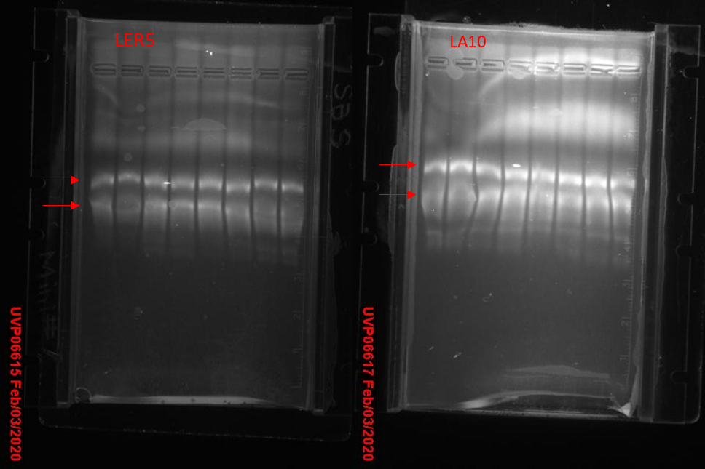

Figure : RNA Gel Electrophoresis

The left and right images show the assigned LER5 and LA10 samples, respectively, both in the second from left well position. There are two clear, nearly uniformly bright, bands for LER5, indicating high levels of intactness of the dominant ribosomal RNA subunits; LA10 shows two bands of varying clarity, suggesting relative degradation. The lack of significant smearing of short-length RNA segments indicates that our samples consist of mostly intact RNA.

*cDNA Synthesis and Primer Standardization*

Our goal for this section of the experiment was to generate cDNA from previously purified RNA samples, which would then be used to validate primer sets for qPCR. After applying DNase to degrade any remaining DNA, we applied reverse transcriptase treatment and ethanol control to each sample. Multiple primer sets were generated and standardized for the genes OLE1 and RD29B. We analyzed melting curves of the primer qPCR reactions, and the single peaks indicated that primers were properly annealing to only target sites. We then standardized our primer sets to establish duplication properties for qPCR. A serial dilution of cDNA was created and Threshold Cycle, or number of PCR cycles before sample fluoresces past an established background level, was recorded for each. The results of the standardization experiment are shown below. The equation given by linear regressions to the standardization data depicts an acceptable level of linearity and DNA duplication for Primer Set 4, which was chosen for use in qPCR.

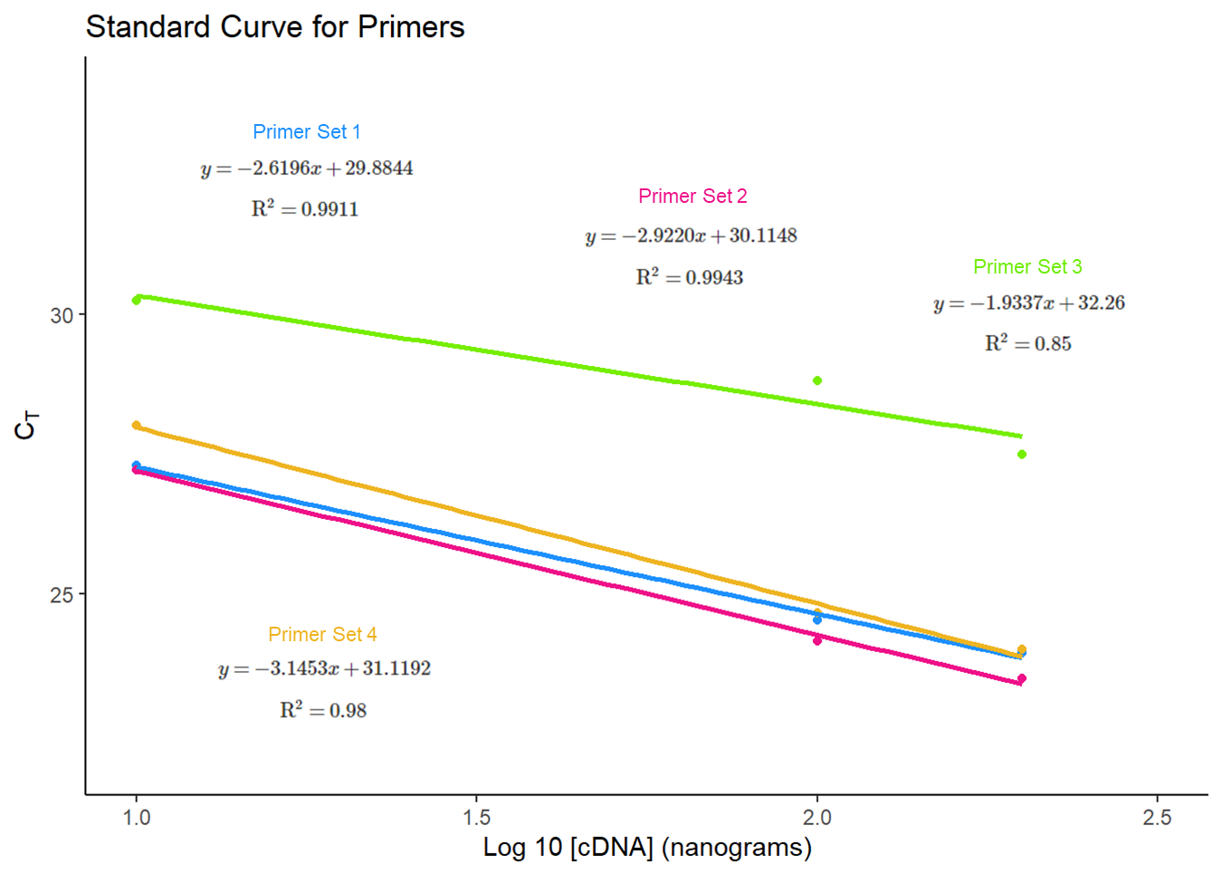

Figure : Primer standardization curves, linear regression formulae use MSE and adjusted-R2

*qPCR*

Our goal for this section of the experiment was to utilize the previously generated cDNA samples, along with the chosen primer set, to quantify the level of gene expression in each sample. This was achieved through measurement of number of threshold cycles for OLE1 and RD29B for each treatment group, which were compared to the number of threshold cycles for the reference gene Actin 2. Three technical replicates and biological replicates for each gene-treatment were used to generate relative fold-change, presented in Figures 3, 4, and 5. Wild-type cDNA treated with ABA showed a somewhat greater expression of OLE1 and significantly greater expression of RD29B compared to the ethanol control group. AGP31-mutant line cDNA treated with ABA showed a near equal expression of OLE1 across ABA and ethanol treatment groups; the line also showed significantly higher RD29B expression for the ABA treatment. The AGP31-rescue line showed greater expression of OLE1 and RD29B for the ABA treatment group.

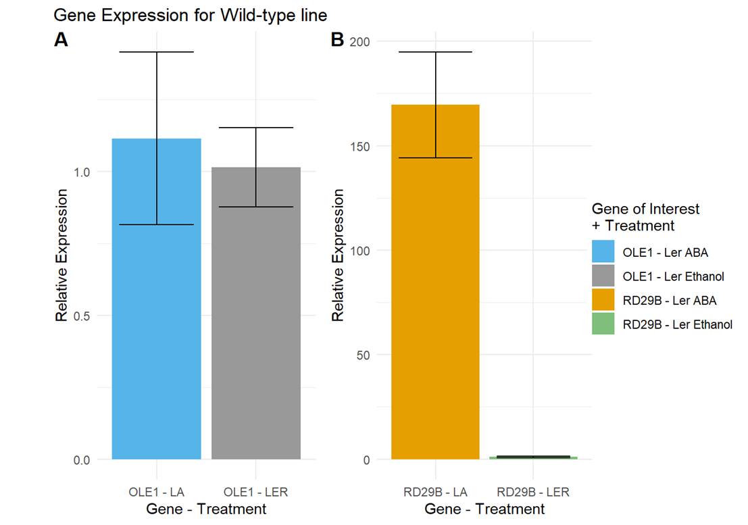

Figure : Mean fold-change by treatment with ±1 MSE error-bars

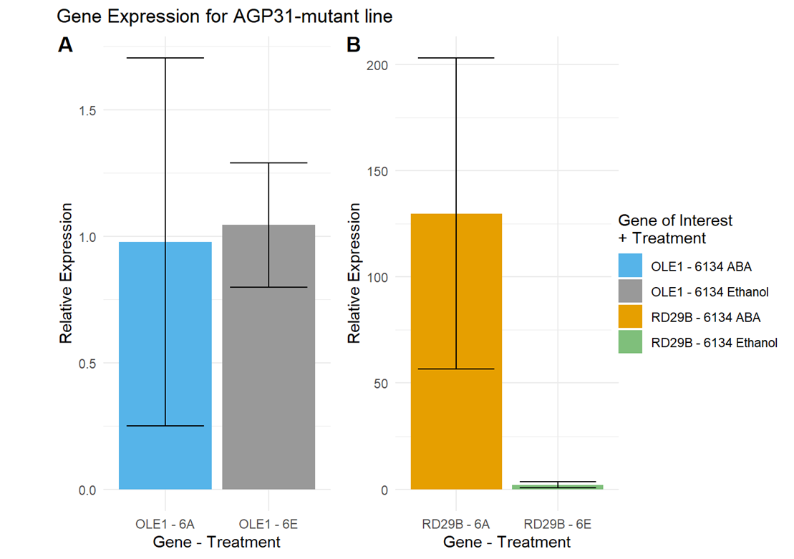

Figure : Mean fold-change by treatment with ±1 MSE error-bars

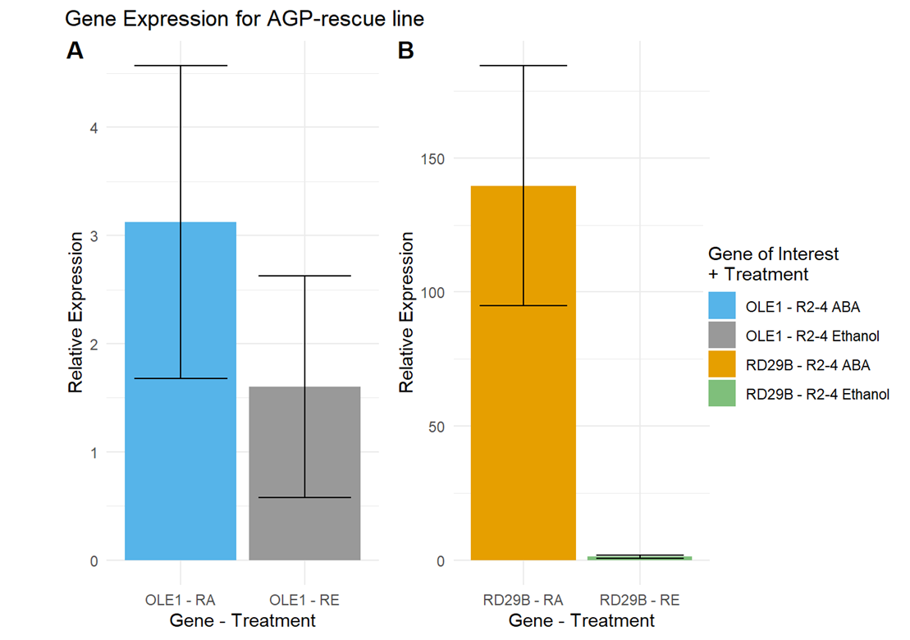

Figure : Mean fold-change by treatment with ±1 MSE error-bars

**Discussion**

This set of experiments was conducted as a lab group to further understanding of the effect of ABA on stress-response protein gene expression in Arabidopsis lines variant for cell wall protein AGP31. This study confirms that the regulation of RD29B and OLE1 stress-response genes by ABA changes based on AGP31 variation; we find that functional AGP31 enables ABA upregulation of OLE1, and AGP31 mutations slightly reduce upregulation of RD29B. This suggests that AGP31 is necessary for OLE1 regulation by ABA, and that alternate pathways for RD29B regulation by ABA may exist.

RNA purification of Arabidopsis tissue powder resulted in a high purity solution of RNA, with low amounts of contaminating reagents, salts, or proteins, validated by spectroscopy. It’s worth noting that nearly all class samples had similarly good measures for yield and purity. Gel electrophoresis revealed fairly distinct bands for all samples, though some samples seem to exhibit some slight smearing; this could be due to contamination with RNases and creation of RNA fragments or could be due to data/image limitations. These issues aren’t major enough to invalidate experiment results but should be validated in later experiments.

The generation of cDNA and standardization of primers prior to qPCR resulted in the selection of an acceptable primer set. A melting curve for each primer set reflected a single peak, indicating that the primers were correctly annealing to the desired sites. The primer sets were then standardized to measure the level of DNA amplification produced in qPCR cycles. Logarithmic cDNA concentration and CT value should have a strong linear relationship, with minimum R2 of 0.990 and slope between -3.1 and -3.6, indicating full DNA duplication. The regression results in Figure 2show that Primer Sets #1, 2, and 4 have strong linear relationships between log 10 cDNA concentration and threshold cycle number; however, the primer standardization curves for Primer Sets #1, and 2 suggest unacceptable levels of DNA duplication. Primer set #4 should be used in subsequent qPCR reactions due to high linearity and near complete DNA replication. The consistent standardization results across replicates and high purity of RNA and cDNA samples suggest that low duplication may have been a result of low sample gene expression. We could address this by pre-amplifying cDNA using an external primer set, so that there may be more cDNA to amplify the genes of interest for each primer set. This may suggest a more suitable primer set than set #4, which could then be used to repeat the qPCR step.

cDNA samples were then used with the acceptable primer set in qPCR to quantify the level of gene expression for our genes of interest. Both reverse transcriptase and RT- samples were run through qPCR, allowing us to verify that RT- samples had no significant amplification, which would suggest the existence of contaminating DNA. Expression for each treatment was compared against that of Actin 2, a gene known to show minimal variation across cell types. We first obtained CT values across treatment groups and performed outlier analysis to obtain a more consistent result. With an outlier definition of greater than 1 cycle from another triplicate, there were some exclusions worth discussing. First, the entire Ler-ABA biological replicate 1 and 6134-Ethanol biological replicate 2 were excluded due to indeterminate results for all genes. Second, the Ler-Ethanol biological replicate 2 CT values for OLE1 were removed due to high variability. These material exclusions resulted in reduction of sample size for the relevant gene-treatments. Similar to the primer set amplification, these outliers could be due to a low expression of genes of interest in the cDNA. However, the valid CT values obtained in other biological replicates suggest these outliers were due to some technical error. A potential modification could be to increase the number of replicates used for each sample, as well as ensure calibration and performance of pipettors in steps requiring high accuracy.

The replicates that were found to be valid were then used to calculate fold-change in gene expression compared to an Ethanol treatment calibrator CT value. All control treatment groups had mean fold-change near 1, while ABA treatment mean fold-change varied based on gene considered and gene line. All 3 cell lines experienced significant ABA upregulation of RD29B, but the AGP31-mutant and AGP-31rescue lines had less drastic effects compared to the wild-type line. OLE1 expression was slightly upregulated by ABA in the wild-type line, slightly downregulated in the AGP31 mutant line and upregulated in the rescue line. These results suggest that ABA interacts with AGP31 cell wall protein to increase upregulation of RD29B but can still contribute to a relatively smaller effect if AGP31 is modified. Additionally, it seems that the effect of ABA on OLE1 expression is positively associated with AGP31 presence. Despite these initial findings, results are complicated by high variability in relative expression results; further trials should be run to validate the findings presented, ideally with greater number of replicates for statistical power. Expansions to this work may consider lines transgenic for multiple cell wall proteins to examine alternate ABA effector pathways. Further investigation of gene expression under treatment of multiple known stress-response hormones, such as jasmonates or cytokins, could also elucidate potential interaction effects of regulation pathways across AGP31 variants.